**Data Analytics**

**Logistic Regression**

**…………………………………………….**

**Name : Modem Praveen Roll no : 17BCS035**

**………………………………………………………….**

**Dataset:** Telecom data

**Objective:** Finding Churn Column (yes/no)

**Read File:** Churn_data <- read.csv(file.choose())

**Structure** : str(Churn_data)

**Output:**

'data.frame': 3333 obs. of 11 variables:

$ Churn : int 0 0 0 0 0 0 0 0 0 0 ...

$ AccountWeeks : int 128 107 137 84 75 118 121 147 117 141 ...

$ ContractRenewal: int 1 1 1 0 0 0 1 0 1 0 ...

$ DataPlan : int 1 1 0 0 0 0 1 0 0 1 ...

$ DataUsage : num 2.7 3.7 0 0 0 0 2.03 0 0.19 3.02 ...

$ CustServCalls : int 1 1 0 2 3 0 3 0 1 0 ...

$ DayMins : num 265 162 243 299 167 ...

$ DayCalls : int 110 123 114 71 113 98 88 79 97 84 ...

$ MonthlyCharge : num 89 82 52 57 41 57 87.3 36 63.9 93.2 ...

$ OverageFee : num 9.87 9.78 6.06 3.1 7.42 ...

$ RoamMins : num 10 13.7 12.2 6.6 10.1 6.3 7.5 7.1 8.7 11.2 ...

**Splitting data as train and test data**

split <- sample.split(Churn_data, SplitRatio = 0.7)

train <- subset(Churn_data, split== "TRUE")

test <- subset(Churn_data, split== "FALSE")

**Training test data with Logistic regression model**

logit_model <- glm(Churn ~ ., data = train, family = "binomial")

summary(logit_model)

……………………………………………………………………..

**Output:**

Call:

glm(formula = Churn ~ ., family = "binomial", data = train)

Deviance Residuals:

Min 1Q Median 3Q Max

-1.7909 -0.5030 -0.3438 -0.2066 3.0779

Coefficients:

Estimate Std. Error z value Pr(>|z|)

(Intercept) -6.263187 0.711442 -8.804 < 2e-16 ***

AccountWeeks 0.001619 0.001778 0.910 0.362579

ContractRenewal -1.936251 0.184798 -10.478 < 2e-16 ***

DataPlan -1.031622 0.715032 -1.443 0.149087

DataUsage 1.717443 2.470877 0.695 0.487009

CustServCalls 0.467424 0.049066 9.526 < 2e-16 ***

DayMins 0.042571 0.041724 1.020 0.307590

DayCalls 0.006207 0.003568 1.740 0.081927 .

MonthlyCharge -0.175187 0.245154 -0.715 0.474855

OverageFee 0.422263 0.418142 1.010 0.312564

RoamMins 0.096792 0.027867 3.473 0.000514 ***

---

Signif. codes: 0 ‘***’ 0.001 ‘**’ 0.01 ‘*’ 0.05 ‘.’ 0.1 ‘ ’ 1

(Dispersion parameter for binomial family taken to be 1)

Null deviance: 1692.5 on 2120 degrees of freedom

Residual deviance: 1349.6 on 2110 degrees of freedom

AIC: 1371.6

Number of Fisher Scoring iterations: 6

………………………………………………………………………

**Output is depending on Intercept , ContractRenewal , CustServCalls and RoamMins.So Iam training only those columns to my model.**

logit_model <- glm(Churn ~ ContractRenewal + CustServCalls + RoamMins , data = train, family = binomial)

**Predicting Churn with test data using before trained model**

fitted.results <- predict(logit_model, test, type = "response")

**some of the results:**

1 3 9 10 12 14 20

0.07701407 0.06188956 0.07002196 0.27491253 0.04910333 0.18476219 0.09564613

21 23 25 31 32 34 36

0.05494303 0.05060039 0.05372502 0.14893143 0.07871615 0.08775261 0.21504788

42 43 45 47 53 54 56

0.33155267 0.11156132 0.04754996 0.19571531 0.12300643 0.10619550 0.07814500

58 64 65 67 69 75 76

0.11940875 0.18835963 0.09822295 0.24601545 0.06553008 0.06097831 0.05776867

78 80 86 87 89 91 97

0.19787037 0.11021712 0.04729104 0.19537396 0.11880734 0.08342440 0.06566309

98 100 102 108 109 111 113

0.20421624 0.11000449 0.07385904 0.07589816 0.07757765 0.06799145 0.25133975

119 120 122 124 130 131 133

0.11156132 0.10177854 0.04254906 0.08649568 0.15372662 0.16867620 0.07425210

135 141 142 144 146 152 153

0.07210843 0.09162296 0.05453416 0.08712209 0.20976043 0.07757765 0.06409329

**Fixing threshold and making outputs as 0 and 1**

fitted.results.new <- ifelse(fitted.results.new > 0.3,1,0)

table(test$Churn, fitted.results.new)

|  |  |  |
| --- | --- | --- |
|  | 0 | 1 |
| 0 | 958 | 57 |
| 1 | 137 | 60 |

**These are my correct and wrong predictions**

**Accuracy**

Error <- mean(fitted.results.new != test$Churn )

print(paste('Accuracy =',1-Error))

**Output**: "Accuracy = 0.83993399339934"

**80% accuracy**

**………………………………………………………….**

**Plots:**

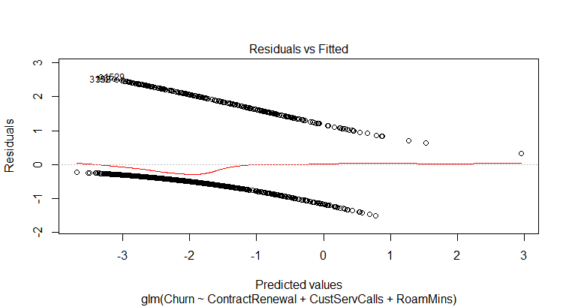**Model:**

**Binarised prediction values:**

